**LAB EXAMINATION – 2 (COMPUTER NETWORKS)**

**(RA2211026050109)**

Objective:

Set up and configure a network topology using RIP and OSPF routing protocols in Cisco Packet Tracer. Customize the network by assigning each computer a name and an IP address using the last three digits of the roll number.

Procedure:

1. NetworkTopologyDesign:
   * Createatopologythatincludes:
     + 10-12 computers distributed across two LANs.
     + Use two switches, each connecting a group of computers in a separate
     + LAN.

Two routers connected via a WAN link.

* + Device Distribution:
    - LAN 1: 5-6 computers connected to Switch 1.
    - LAN 2: 5-6 computers connected to Switch 2.
  + Device Naming Convention:
    - Each computer was assigned a name in the format: PC_RollNumber (e.g., PC_123).

1. IP Address Configuration:
   * AssignIPaddressestothecomputersineachLAN.
     + LAN 1: IP addresses configured with the subnet 192.168.1.0/24, where each PC's IP address ends with the last three digits of the roll number (e.g., 192.168.1.123 for PC_123).
     + LAN 2: IP addresses configured with the subnet 192.168.2.0/24, similarly using the roll number for the last octet (e.g., 192.168.2.123

for PC_123).

* + Router Interface Configuration:
    - Router 1 interfaces were set up with the IP address 192.168.1.1/24 for
    - LAN 1.
    - Router 2 interfaces were configured with 192.168.2.1/24 for LAN 2. The WAN link between routers used a point-to-point subnet (e.g., 10.0.0.1/30 for Router 1 and 10.0.0.2/30 for Router 2).

1. Routing Protocols Configuration: o ConfigureRIPv1onRouter1:

* Added the network commands for 192.168.1.0 and 10.0.0.0 to enable RIP routing.
  + Configure OSPF on Router 2:
    - OSPF was set up using the area 0 configuration.
    - Added network commands for 192.168.2.0 and 10.0.0.0.
  + Ensuring Communication:
    - Verified that the routes were properly advertised and shared between the two routing protocols using route redistribution.

1. Packet Tracer Configuration Steps:
   * Add Devices and Create Connections:
     + Placed all computers, switches, and routers in the workspace.
     + Connected devices with appropriate cabling (copper straight-through for computers to switches and serial connections for routers).
   * Configure IP Addresses:
     + Manually set IP addresses for all computers and configured default gateways.
   * Set Up Routing:
     + Enabled RIP on Router 1 and OSPF on Router 2.
     + Configured route redistribution on both routers for seamless

communication.

* + Verification:

▪

▪

1. Simulation:

Used the ping command to test connectivity between LAN 1 and

LAN 2.

Verified route tables on both routers to ensure correct route advertisement.

* CiscoPacketTracerSimulationMode:
  + Switchedtosimulationmodetoobservepackettransmission.
  + InitiatedmessagesendingfromacomputerinLAN1toacomputerin LAN 2.
  + Verifiedthesuccessfultransmissionofthemessageandinspected routing paths.

1. Documentation and Submission:

* ProcedureDocumentation: Step-by-step process of network configuration

was documented as described above.

* Screenshots: Added all relevant screenshots, covering network design, IP

configurations, and successful message transmission.

* PacketTracerFile:
* GitHubSubmission:

Saved the .pkt file with the completed configuration. Uploaded all documents, screenshots, and the .pkt file

to a GitHub repository named "Lab 2 Exam".

* RepositorySubmission: Submitted the GitHub repository link to the instructor.

Output Screenshots:

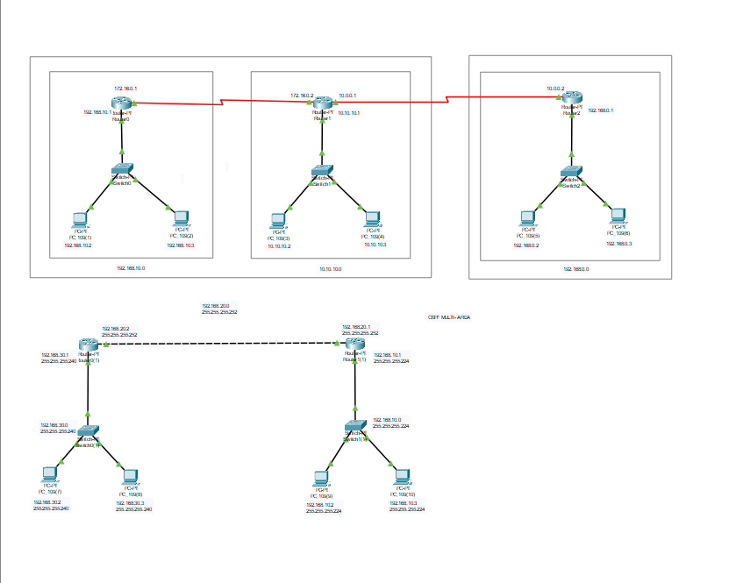

Results:

* Successfully configured a network topology with two LANs using RIP and OSPF routing protocols.
* All devices were assigned IP addresses based on the last three digits of the roll number, maintaining the required subnet structure.
* Routing protocols were configured on the routers, allowing seamless communication between LAN 1 and LAN 2.
* The simulation mode in Cisco Packet Tracer demonstrated successful packet transmission across the network.
* Documentation and files were submitted as per the requirements.

Name: DhanyaaSU

Class: AIML – B

Reg.No: RA2211026050109

Githhub Link: [Dhanprit (S.U.Dhanyaa) (github.com)](https://github.com/Dhanprit)